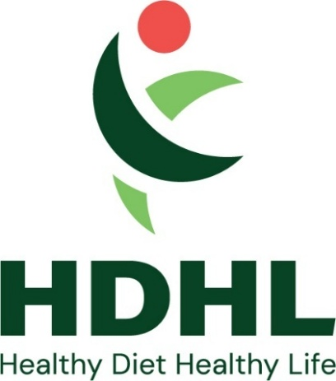
Name and address of organisation leader

Expression of Interest Letter
for participation in the
HDHL Knowledge Hub call - “Establishing the link between food processing and sustainable food systems”
We hereby confirm that [organisation/institution] intends to participate in the establishment and implementation of the above-mentioned Funding Action “Establishing the link between food processing and sustainable food systems”.
The overall aim of the Knowledge Hub is to foster transnational and multidisciplinary collaboration and networking in order to accelerate, further develop and increase the scientific and policy-relevant understanding of the relationship between food processing and sustainable food systems.
[Prof./Dr./other] [function] will represent the [institution/organisation] within the Food processing Policy Implementation Network.

Date:
Signature of the main applicant
(Name)

Signature of the applicant’s institution / organisation
(Name)

